**Game screen elements subsystem**

**GameUIScreen class**



It holds the list of UI Objects.

**UIObject Class**

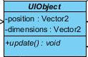

#### Attributes:

Private Vector2 position: It keeps the position of the objects.

Private Vector2 dimensions: It keeps the size of the objects.

#### Methods:

Public void update():

**Icon Class**



#### Attributes:

Private Image icon: It holds an images of the icons.

**PowerUpStatus Class**

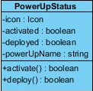

#### Attributes:

Private Icon icon: It holds an icon of the power ups.

Private boolean activated: It holds whether the power up is activated or not.

Private boolean deployed: I: It holds whether the power up is activated or not.

Private string powerUpName: : It holds power up’s name.

#### Methods:

Public boolean activate():This method activates the power up and it returns whether the power up is activated or not.

public boolean deploy():This method deploys the power up and it returns whether the power up is deployed or not.

**IconXAmount Class**



#### Attributes:

Private Icon icon: It holds an icon the items.

Private int amount: It holds an amount of the items.

**Layer Class**

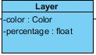

Private Color color: It holds an color of the layer.

Private float percentage: It holds an percentage of the layer.

**Multibar Class**

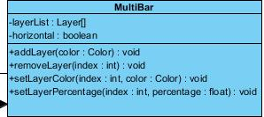

#### Attributes:

Private Layer[] layerList :It holds an list of the layer.

Private boolean horizontal: It holds the direction of the layer.

#### Methods:

Public void addLayer(color : Color): This method adds the new layer and it does not return anything.

Public void removeLayer(Index : int): This method removes the existing layer and it does not return anything.

Public void setLayerColor(Index : int, color : Color): This method sets the color of the existing layer layer and it does not return anything.

Public float setLayerPercentage(Index : int, percentage : float): This method sets the percentage of the existing layer layer and it returns the percentage.